*STOCK PERFORMANCE ANALYSIS*



*BRIEF OVERVIEW*

Goldman Sachs is one of the world's leading investment banks and financial services companies. Founded in 1869 by Marcus Goldman, the firm has grown to become a global powerhouse in finance. Goldman Sachs provides a wide range of services including investment banking, asset management, securities trading, and investment management for institutions, corporations, governments, and individuals.

Over the years, Goldman Sachs has played a significant role in shaping global financial markets. The firm is known for its expertise in mergers and acquisitions, underwriting of public offerings, trading of equities, fixed income, currencies, and commodities, as well as providing advisory services to its clients.Goldman Sachs has faced scrutiny and criticism at times, particularly during the 2008 financial crisis, and has adapted its business model in response to regulatory changes and market conditions. Despite challenges, it remains a dominant force in the financial industry and continues to be influential in global markets.

The firm is renowned for its role in mergers and acquisitions, underwriting of securities, and providing advisory services to corporations, governments, and wealthy individuals. Goldman Sachs is also heavily involved in trading, both in traditional financial instruments like stocks and bonds, as well as more complex products like derivatives.Over the years, Goldman Sachs has faced both praise and criticism for its influence in global finance. It has been a key player in numerous high-profile transactions and has cultivated a reputation for attracting top talent in the finance industry. However, it has also faced scrutiny for its role in the 2008 financial crisis and various controversies surrounding its business practices.

* *HISTORICAL PRICE DATA*

Previous Close 410.71

Open 404.01

Bid 402.91 x 800

Ask 402.94 x 800

Day's Range 397.34 - 405.45

52 Week Range 289.36 - 419.20

Volume 725,205

Avg. Volume 2,294,627

Market Cap 130.238B

Beta (5Y Monthly) 1.42

PE Ratio (TTM) 17.54

EPS (TTM) 22.88

Earnings Date Apr 15, 2024

Forward Dividend & Yield 11.00 (2.65%)

Ex-Dividend Date Feb 28, 2024

1y Target Est 432.29

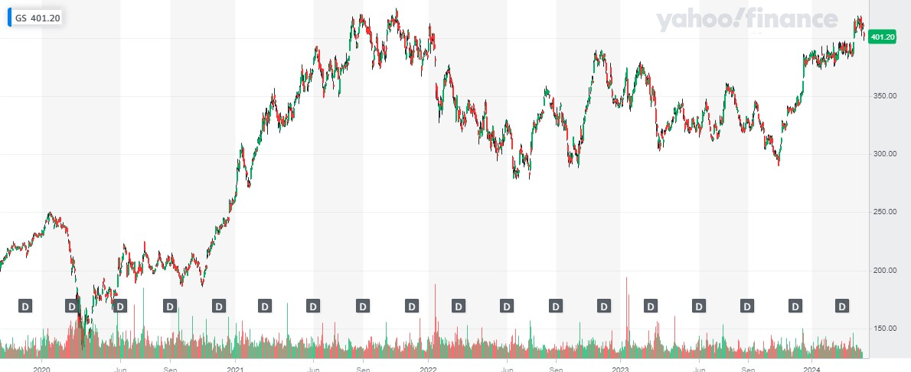

Chart showing the historical price data

* *KEY METRICS*

|  |  |
| --- | --- |
| Exchange | NYSE |
| Sector | Financial Services |
| Industry | Capital Markets |
| Common Shares Outstanding | 324.53M |
| Free Float | 322.77M |
| Market Capitalization | $128.99B |
| Average Volume (Last 20 Days) | 1.99M |
| Beta (Past 60 Months) | 1.43 |
| Percentage Held By Insiders (Latest Annual Proxy Report) | 0.54% |
| Percentage Held By Institutions (Latest 13F Reports) | 71.21% |
| Annual Dividend (Based on Last Quarter) | $11.00 |
| Dividend Yield (Based on Last Quarter) | 2.77% |

|  |  |
| --- | --- |
| Revenue (Most Recent Fiscal Year) | $108.42B |
| Net Income (Most Recent Fiscal Year) | $8.52B |
| PE Ratio (Current Year Earnings Estimate) | 12.00 |
| PE Ratio (Trailing 12 Months) | 17.42 |
| PEG Ratio (Long Term Growth Estimate) | 1.53 |
| Price to Sales Ratio (Trailing 12 Months) | 1.19 |
| Price to Book Ratio (Most Recent Quarterly Book Value per Share) | 1.23 |
| Price to Cash Ratio (Most Recent Annual Cash Flow per Share) | 9.69 |
| Pre-Tax Margin (Trailing 12 Months) | 23.22% |
| Net Margin (Trailing 12 Months) | 7.85% |

|  |  |  |
| --- | --- | --- |
| Return on Equity (Trailing 12 Months) | 8.03% | |
| Return on Assets (Trailing 12 Months) | 0.54% | |
| Current Ratio (Most Recent Fiscal Quarter) | 0.76 | |
| Quick Ratio (Most Recent Fiscal Quarter) | 0.76 | |
| Debt to Common Equity (Most Recent Fiscal Quarter) | 2.29 | |
| Inventory Turnover (Trailing 12 Months) | -- | |
| Book Value per Share (Most Recent Fiscal Quarter) | $324.13 | |
| Earnings per Share (Most Recent Fiscal Quarter) | $5.48 | |
| Earnings per Share (Most Recent Fiscal Year) | $22.87 | |
| Diluted Earnings per Share (Trailing 12 Months) | $22.82 | |
| **Volatility Metrics** |
| **Historical Volatility (Close-to-Close)** | **0.2528** |
| [Historical Volatility (Parkinson)](https://www.alphaquery.com/stock/GS/volatility-option-statistics/30-day/parkinson-historical-volatility) | [0.1909](https://www.alphaquery.com/stock/GS/volatility-option-statistics/30-day/parkinson-historical-volatility) |
| [Implied Volatility (Calls)](https://www.alphaquery.com/stock/GS/volatility-option-statistics/30-day/iv-call) | [0.2630](https://www.alphaquery.com/stock/GS/volatility-option-statistics/30-day/iv-call) |
| [Implied Volatility (Puts)](https://www.alphaquery.com/stock/GS/volatility-option-statistics/30-day/iv-put) | [0.2725](https://www.alphaquery.com/stock/GS/volatility-option-statistics/30-day/iv-put) |
| [Implied Volatility (Mean)](https://www.alphaquery.com/stock/GS/volatility-option-statistics/30-day/iv-mean) | [0.2678](https://www.alphaquery.com/stock/GS/volatility-option-statistics/30-day/iv-mean) |
| [Put-Call Implied Volatility Ratio](https://www.alphaquery.com/stock/GS/volatility-option-statistics/30-day/put-call-iv-ratio) | [1.0364](https://www.alphaquery.com/stock/GS/volatility-option-statistics/30-day/put-call-iv-ratio) |
| [Implied Volatility Skew](https://www.alphaquery.com/stock/GS/volatility-option-statistics/30-day/iv-mean-skew) | [0.0287](https://www.alphaquery.com/stock/GS/volatility-option-statistics/30-day/iv-mean-skew) |

|  |  |
| --- | --- |
| **Option Statistics** | |
| [Put-Call Ratio (Volume)](https://www.alphaquery.com/stock/GS/volatility-option-statistics/30-day/put-call-ratio-volume) | [0.6984](https://www.alphaquery.com/stock/GS/volatility-option-statistics/30-day/put-call-ratio-volume) |
| **Put-Call Ratio (Open Interest)** | **0.7235** |
| [Forward Price](https://www.alphaquery.com/stock/GS/volatility-option-statistics/30-day/forward-price) | [390.79](https://www.alphaquery.com/stock/GS/volatility-option-statistics/30-day/forward-price) |
| [Call Breakeven Price](https://www.alphaquery.com/stock/GS/volatility-option-statistics/30-day/call-breakeven) | [427.04](https://www.alphaquery.com/stock/GS/volatility-option-statistics/30-day/call-breakeven) |
| [Put Breakeven Price](https://www.alphaquery.com/stock/GS/volatility-option-statistics/30-day/put-breakeven) | [361.00](https://www.alphaquery.com/stock/GS/volatility-option-statistics/30-day/put-breakeven) |
| [Option Breakeven Price](https://www.alphaquery.com/stock/GS/volatility-option-statistics/30-day/option-breakeven) | [399.79](https://www.alphaquery.com/stock/GS/volatility-option-statistics/30-day/option-breakeven) |

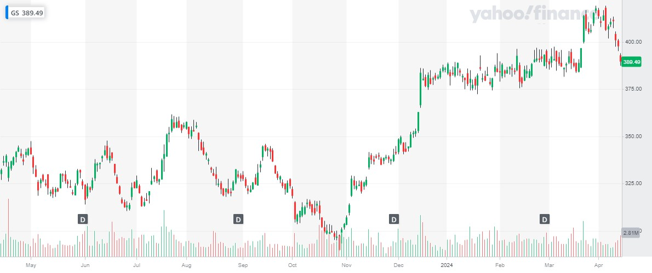

*Key metrics/price change percentage and voltality chart*

*Goldman Sachs is selling for under****389.49****as of the 13th of April 2024; that is -2.01 percent decrease since the beginning of the trading day. The stock's lowest day price was****387.12****. Goldman Sachs has only four percent chance of going through some form of*[*financial distress*](https://www.macroaxis.com/financials/GS/Goldman-Sachs-Group)*over the next 2 years but had a somewhat*[*insignificant*](https://www.macroaxis.com/performance/GS/Goldman-Sachs-Group)*performance during the last****90****days. Equity ratings for Goldman Sachs Group are calculated daily based on our*[*scoring framework*](https://www.macroaxis.com/invest/macroaxisScoreInfo)*. The performance scores are derived for the period starting the*[*14th of January 2024*](https://www.macroaxis.com/invest/modelInputSave)*and ending today, the****13th of April 2024****.*

|  |  |  |
| --- | --- | --- |
| ***Business Domain***  ***Financial Services*** | ***IPO Date***  ***3rd of May 1999*** | ***Classification***  ***Financials*** |

*The Goldman Sachs Group, Inc., a financial institution, provides a range of financial services for corporations, financial institutions, governments, and individuals worldwide. The company was founded in 1869 and is headquartered in New York, New York. The company has 324.53****M****outstanding shares of which 5.09****M****shares are currently sold short in the market by investors with about 2.17 days to cover all shorted shares.*

*Goldman Sachs' financial strength is of vital concern to both outside investors and internal stakeholders. Efficiency and cost control are keys to Goldman Sachs' success, along with its ability to generate sufficient cash flow to pay bills, repay debt, and make a consistent year-to-year profit.*

*Goldman Sachs' bond ratings measure its*[*overall creditworthiness*](https://www.macroaxis.com/invest/bond/GS)*, which in many ways corresponds to the cost of borrowing for an issuer. These ratings assign a letter grade to all of Goldman Sachs' outstanding corporate bonds that indicate their credit quality. We use reports published by private self-sufficient rating services such as Standard & Poor's or Fitch Ratings Inc. to evaluate a bond issuer's financial strength or its ability to pay a bond's principal and interest.*

*Financial leverage usually refers to the use of borrowed funds to amplify returns from an investment. In general, analyzing the relationship between debt to total assets helps investors to understand Goldman Sachs' financial leverage. It provides some insight into what part of Goldman Sachs' total assets is financed by creditors.*

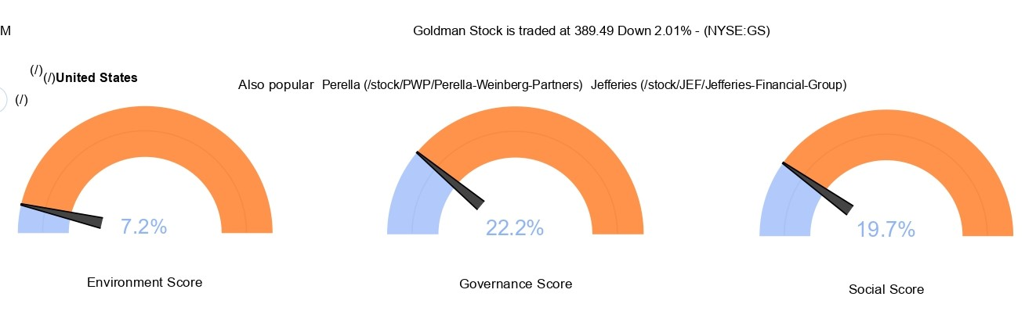

*AVERAGE TRADE VOLUME*

*The chart above depicts the distribution of trading volume for companies operating in the Financials sector in the Developed economic region. Over 10,740 companies were considered in this analysis, and 10,526 had meaningful values. The average trading volume of companies in the sector is 162.381 K with a standard deviation of 502.222 K.*

*Goldman Sachs Group Inc's Trading Volume of 1.182 M ranks in the 95.4% percentile for the sector. The following table provides additional summary stats:*

|  |  |
| --- | --- |
| *Trading Volume In The Financials Sector* | |
| *Economic Risk Region* | *Developed* |
| *Total Constituents* | *10,741* |
| *Included Constituents* | *10,526* |
| *Min* | *0 K* |
| *Max* | *4.623 M* |
| *Median* | *8.519 K* |
| *Mean* | *162.381 K* |
| *Standard Deviation* | *502.222 K* |

*COMPARISON OF PERFORMANCE OF STOCK*

*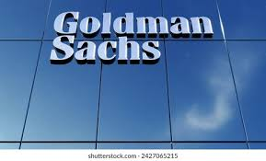 VS 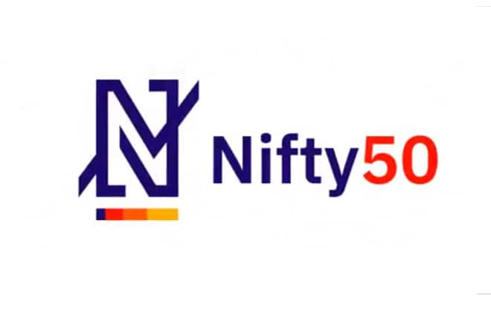*

|  |  |  |
| --- | --- | --- |
| *Exchange* | *NYSE* | *NASDAQ* |
| *Open* | *404.06* | *55.95* |
| *High* | *408.00* | *56.22* |
| *Low* | *403.01* | *55.74* |
| *Last* | *404.00* | *56.04* |
| *Change* | *+0.89* | *+0.38* |
| *% Change* | *+0.22%* | *+0.68%* |
| *Volume* | *2,805,400* | *85,700* |
| *20-Day Average Volume* | *2,387,485* | *27,825* |
| *Previous Close* | *403.11* | *55.66* |
| *Industry* | *Finance - Investment Brokers* | *N/A* |
| *Has Options* | *Yes* | *Yes* |

|  |
| --- |
| **Technicals** |
| 20-Day Moving Average | 406.03 | 56.62 |
| 20-Day Raw Stochastic | 52.62% | 32.50% |
| 20-Day Relative Strength | 53.39% | 47.27% |
| Weighted Alpha | +23.12 | +27.65 |
| Today's Opinion | 72% Buy | 40% Buy |
| Previous Opinion | 72% Buy | 40% Buy |
| Last Month's Opinion | 100% Buy | 56% Buy |

|  |  |  |
| --- | --- | --- |
| **Performance** | | |
| **5-Days** |
| %Chg | +3.73% since 04/12/24 | -0.46% since 04/12/24 |
| Low | 395.18 on 04/16/24 | 55.12 on 04/18/24 |
| High | 412.86 on 04/15/24 | 56.65 on 04/15/24 |
| **1-Month** |
| %Chg | +3.95% since 03/19/24 | +0.97% since 03/19/24 |
| Low | 386.00 on 03/20/24 | 55.12 on 04/18/24 |
| High | 419.20 on 03/28/24 | 57.95 on 04/08/24 |
| **3-Month** |
| %Chg | +5.70% since 01/19/24 | +3.05% since 01/19/24 |
| Low | 374.24 on 01/29/24 | 53.37 on 01/23/24 |
| High | 419.20 on 03/28/24 | 58.25 on 03/08/24 |
| **6-Month** |
| %Chg | +35.03% since 10/19/23 | +14.91% since 10/19/23 |
| Low | 289.36 on 10/27/23 | 46.60 on 10/26/23 |
| High | 419.20 on 03/28/24 | 58.25 on 03/08/24 |

|  |
| --- |
| ***Key Statistics*** |
| *Market Capitalization, $K* | *131,108,912* | *196,140* |
| *Shares Outstanding, K* | *324,527* | *3,500* |
| *Annual Sales* | *46,254,000,000* | *0* |
| *Annual Net Income* | *8,516,000,000* | *0* |
| *Last Quarter Sales* | *11,318,000,000* | *N/A* |
| *Last Quarter Net Income* | *2,008,000,000* | *N/A* |
| *60-Month Beta* | *1.43* | *0.72* |

|  |
| --- |
|  |
| **Per-Share Information** |
| Most Recent Earnings | 11.58 on 04/15/24 | N/A |
| Latest Earnings Date | 04/15/24 | N/A |
| Most Recent Dividend | 2.750 on 02/28/24 | 0.079 on 03/21/24 |
| Next Ex-Dividends Date | 05/30/24 | 03/21/24 |
| **Ratios** |
| Price/Earnings ttm | 15.74 | 17.01 |

* *KEY EVENTS*

***NTPC shares surge over 3% on Goldman Sachs' bullish rating***

*Goldman Sachs projects a 42 percent upside with NTPC's advantage in India's renewable transition and rising peak power demand. Tata Power is downgraded to 'Sell' due to earnings headwinds.*

*NTPC shares gained over 3 percent, reaching Rs 193.60 at 1:34 pm on July 19, after foreign brokerage firm Goldman Sachs bestowed a favourable buy rating on the power sector giant, considering it as a top pick.*

*Goldman Sachs initiated the buy rating on NTPC with a target price of Rs 265, indicating a potential upside of 42 percent.*

*The brokerage firm outlined two pivotal themes shaping India's power sector and influencing NTPC's growth prospects. Firstly, the economics-led renewable transition is gaining momentum, driven by the viability of round-the-clock renewables. This transformative approach offers traditional utilities like NTPC the opportunity to unlock a superior business model, leading to higher returns and access to a broader customer base.*

*Secondly, there is a concurrent onset of a peak power deficit cycle, attributed to a consistent rise in peak demand, which is met with insufficient 'firm' capacity addition. In this context, NTPC's strategic advantage of low-cost debt serves as a robust moat, positioning the company as a frontrunner in this transition.*

*Goldman Sachs posts an earnings beat as growth for its stock-trading business triples estimates Goldman's profits for the three months ending December 31 jumped 51% year-over-year to just over $2 billion, or $5.48 per share – way clear of the $3.51 per share figure analysts polled by Refinitiv had been expecting.The strong performance of the bank's equity-trading business helped it log those forecast-beating results. Revenue from the division rose 26% to $2.6 billion, more than tripling the growth that had been projected by analysts, reflecting a quarter where the stock market soared thanks to resilient growth and investors' expectation that the Federal Reserve will soon start slashing interest rates.Its total revenue for the quarter came in at $11.3 billion, slightly higher than Wall Street's prediction of $10.8 billion.Goldman had previously positioned 2023 as a transitional year where it would pivot away from its consumer banking business, which had racked up billion-dollar losses.*

*This was a year of execution for Goldman Sachs," Solomon said. "With everything we achieved in 2023 coupled with our clear and simplified strategy, we have a much stronger platform for 2024."*

*Revenue for its asset and wealth management department climbed 23% to $4.4 billion, but its investment banking division brought in just $1.7 billion, which represented a 12% drop.*

*Shortly after the opening bell, shares had fallen 0.5% to trade at just under $376 as of 9:45 a.m. Eastern Time.*

*THANK YOU*

**

*BY*

*GLORIA SAGAR*

*DR LANKAPALLI BULLAYA COLLEGE  
ANDHRA UNIVERSITY  
VISAKHAPATNAM*

*121128807021*